Template - Finance, Audit and Risk Committee Charter

Context
The Sports Governance Principles specify that an organisation should clearly define and document its structure and the duties, responsibilities and powers of members, directors, committees and management.

Background
The purpose of a Finance, Audit and Risk Committee charter is to clearly define the respective roles, responsibilities and authorities of the board of directors (both individually and collectively) and management in setting the direction, the management and the control of the organisation.

Although the specific circumstances and environment of each sporting organisation will differ, this template is suggestive of the sorts of matters that may be included but should not be seen as required or exhaustive. The charter should be reviewed in line with the organisation’s constitution and amended accordingly. The board should lead the process of updating and tailoring the content to ensure the final document reflects their own environment and can play an active part in strengthening the culture and governance of their specific organisation.

How to use this document
- This document has been designed as a template. Fields highlighted in yellow should be filled out with the information relevant to your organisation.
- Please note that this guidance and template are general in nature and must be tailored to the requirements of your sporting organisation.
- This document does not constitute legal advice and should not be relied upon as legal advice. We recommend seeking further professional advice should you have any specific queries.

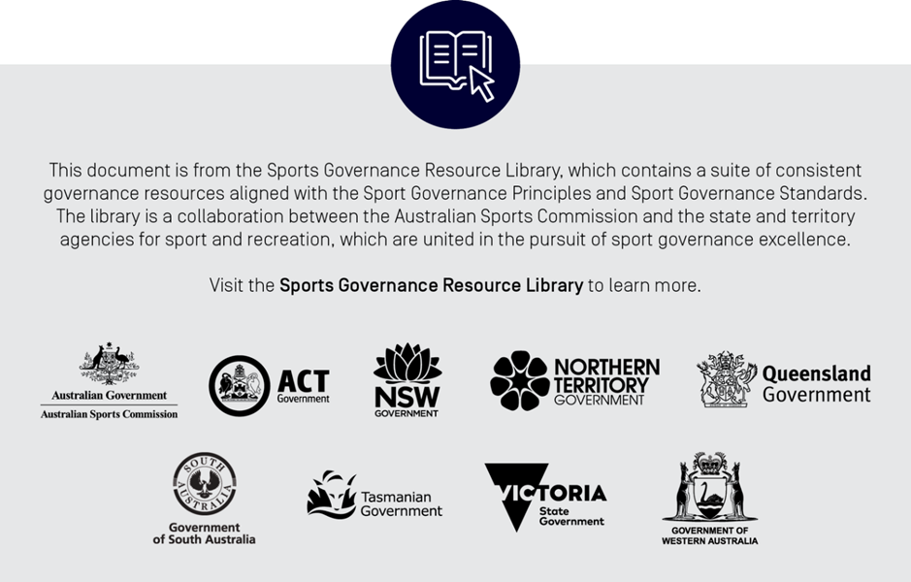

[Insert organisation]

Finance, Audit and Risk Committee Charter

The purpose of this charter is to clearly define the respective roles, responsibilities, and authorities of the Board’s Finance, Audit and Risk sub-committee. Although each charter will be different, this template is indicative of matters that may be included but should not be seen as required or exhaustive.

Foundation
  - Purpose
The Finance, Audit and Risk Committee (the Committee) appointed by the Board assists the Board in fulfilling its oversight responsibilities relating to the:
- preparation and integrity of [insert organisation’s] annual budget, financial accounts and statements
- review of the organisation’s budget and quarterly financial performance or as otherwise required
- review of business cases outside of approved budget
- internal controls, policies and procedures that [insert organisation] uses to identify and manage business risks
- [insert organisation’s] insurance activities
- qualifications, independence, engagement, fees, and performance of [insert organisation’s] external auditor
- External auditor’s annual audit of [insert organisation’s] financial statements
- [insert organisation’s] compliance with legal, regulatory requirements and compliance policies.

The existence of the Committee does not imply the fragmentation or diminution of the role of the Board to ensure the integrity of [insert organisation’s] financial reporting.
  - Authority
The Board has authorised the Committee, within the scope of their duties and responsibilities set out in this charter to:
- perform the activities required to address its responsibilities and make recommendations to the Board
- resolve any disagreement between management and the external auditor, with areas of significant disagreement advised to the Board
- select, engage, and approve fees for any professional advisers that the Committee may require to carry out its duties
- require the attendance of any of [insert organisation’s] manager or staff members at meetings as appropriate; and
- have unrestricted access to management, employees and information it considers relevant to its responsibilities under this charter.

  - Membership
The Committee appointed by the Board shall comprise at least three Members.
The Committee Members shall be:
- “financially literate” as defined by the Board (i.e. able to read and understand financial statements and challenge information presented in Committee meetings); and
- have at least one external and independent Member who shall be a Certified Practicing Accountant or Chartered Accountant.
Committee member rotation is encouraged.
The Company Secretary or their designate is the Committee Secretary.
  - Chairperson
Following consultation with the Directors, the Board Chairperson proposes the Committee Chairperson for approval by the Board.
The Committee Chairperson must not be the Chairperson of the Board.
Should the Committee Chairperson be absent from a meeting, the Committee Members present must appoint a Chairperson for that particular meeting, who should not be the Chairperson of the Board.
  - Education
The Board is responsible for providing new Committee members with an appropriate induction program and ongoing educational opportunities.
  - Meetings
The Committee must meet at least four times per year and participants may attend by video conference (including Skype) and/or teleconference.
The Committee Chairperson, any Committee Member or the Committee Secretary may call a meeting of the Committee.
  - Meeting Attendance
Any person may be invited by the Committee Chairperson to attend meetings of the Committee, but not necessarily for the full duration of the meeting. A standing invitation shall be issued to:
- Chief Executive Officer
- Chief Financial Officer/Finance Manager
- Engagement Partners of the External Audit Firm
  - Quorum and Voting
A quorum must consist of two members of the Committee.
The Committee Chairperson shall not have a second or casting vote.

  - Minutes
The Committee Secretary or delegate must prepare the minutes of the Committee within seven (7) working days. After the Committee Chairperson has given preliminary approval, the draft minutes are circulated to all Committee members and the other Directors.
  - Reviews
The Committee will review at least annually this Committee charter and recommend to the Board for approval any appropriate amendments.

Duties and Responsibilities
In assisting the Board in fulfilling their responsibilities, the duties of the Committee shall be:
  - Assessment of financial information

- Conduct or authorise investigations into any matters within its scope of responsibility, including retention of independent external advisors as it considers necessary.
- Review any significant accounting and reporting issues, including professional and regulatory announcements and to understand their effect on the Organisation’s financial statements.
- Review the annual financial statements of [insert organisation’s] which require approval of the Board and discussion of the financial statements with the External Auditor and management before submission to the Board.
- Review, at least annually, the written attestations provided by the CEO and CFO/Finance Manager.
- Review, for potential conflicts of interest situations, and pre-approve all related party transactions on an on-going basis.
  - External Auditor
- Recommend to the Board the appointment, evaluation, and dismissal of the external auditor, including independence matters.
- Review and approve the external auditor’s proposed audit plan and audit approach, including materiality levels.
- Review and agree on the terms of engagement and the audit fees for the external auditor prior to the commencement of each audit.
- Review the external auditor’s summary management report, detailing the results and significant findings from the audit, and management responses.
- Meet regularly with the external auditor, without management present.
  - Business Risks and Internal Controls
- Recommend the approval of [insert organisation’s] risk management policy to the Board and oversee the risk management system and its resourcing.
- Recommend to the Board and monitor [insert organisation’s] risk profile developed by management, covering the principal enterprise-wide risks, including strategic, operational, legal and financial.
- Review the operational effectiveness of the policies and procedures to risk and [insert organisation’s] internal control environment.
- Review the effectiveness of [insert organisation’s] insurance activities.

  - Compliance
- Review the effectiveness of [insert organisation’s] approach to achieving compliance with laws, regulations, industry codes and [insert organisation’s] policies.
- Review any correspondence from regulatory bodies regarding significant issues.
- Ensure that there is a process for the Board Chairperson and Committee Chairperson to be immediately informed of any issues of significant non-compliance or litigation; when implemented.
  - Reporting
- The Committee Chairperson will report to the Board on the Committee meetings regarding all relevant matters and appropriate recommendations in a written report (with supporting material) for noting or approval by the Board.
- The Committee Chairperson will ensure that the Board Chairperson and the Board are immediately informed of matters that may impact significantly on the financial condition or reputation of the Organisation.

- Audit and Risk Committee Annual Agenda
Scheduled meetings
Structure and skills
Review Audit and Risk Committee charter and Annual Agenda
Assess Committee’s independence, financial literacy, skills and experience
Establish number of meetings for forthcoming year
Committee Chairperson to establish meeting agenda and required attendees
Enhance financial literacy - update on current financial events
Perform an evaluation assessment on the Committee’s and individual Member’s performance
Assessment of financial information
Review significant accounting and reporting issues
Review financial matters affecting the year end
Review and approve annual financial statements
Review attestations of the CEO and CFO/FM for Australian reporting standards
Review with Management its evaluation of [insert organisation’s] internal control structure and procedures for financial reporting, including any significant deficiencies or material weaknesses
Review and discuss any reports submitted by the External Auditor detailing any instances of fraud or possible illegal acts on the part of Senior Management
Review process, policies and procedures for continuous disclosure obligations
Review conflicts of interest and related party transactions
External Auditors
Recommend appointment and review performance
Review audit plan and scope of audit work and any changes thereto
Approve audit fees and terms of engagement
Consider policy in relation to non-audit services
Review and pre-approve non-audit services
Consider objectively the independence of the External Auditor, including obtaining written confirmation of their independence
Review the External Auditor’s report and findings and progress on Management actions
Discuss any significant changes in accounting standards
Discuss appropriateness of accounting policies, estimates and judgments
Discuss the External Auditors’ view on control environment, including fraud risk management
Resolve any disagreement between Management and the External Auditor in the financial reporting and report any significant issues to the Board
Discuss issues with the External Auditor in the absence of Management
Review report from the External Auditor on quality control procedures
Review the External Auditor’s process for rotation
Business Risk and Internal Controls
Recommend the approval of the risk management policy to the Board
Review and monitor business risks and internal controls and report to the Board
Ensure executive remuneration risk and controls are linked to the overall risk profile
Review insurance activities
Reporting
Maintain minutes and report to the Board

